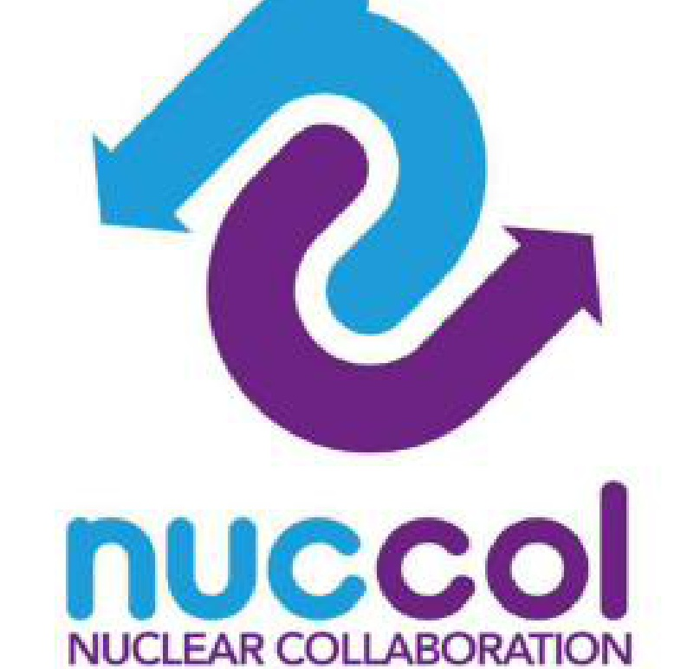
Specification Change Request / Change Notice
Working Tool | PE-10b | Process Excellence | Fit For Nuclear Toolkit
The controlled form for requesting, assessing, approving and implementing a change to a drawing, specification, or work instruction
Document control
Version | Date | Author | Summary of change
1.0 |  |  | First issue
1. Why this form matters
A specification change is any change to a drawing, specification, work instruction, or other controlled document that affects what is made, how it is made, or how it is checked. Even a small change, such as a tolerance moving from 0.5 mm to 0.3 mm, can have consequences for tooling, inspection, and existing stock that are easy to miss if the change is made informally.
This form exists to make sure every change is requested, assessed, approved, and implemented in a controlled way, with a clear record of what changed, why, who agreed it, and what else needed to update as a result. It is the link between a change being agreed and the Drawing and Specification Register (PE-10a) being updated correctly.
One principle above all: no drawing, specification, or work instruction changes on the shopfloor until this form has been completed and approved. An informal change that is not recorded here is the most common cause of parts being made to the wrong revision.

2. How to use this form
- Complete Section 3 to raise a Specification Change Request (SCR). This describes what needs to change and why, and can be raised by anyone: an operator who has spotted a problem, a customer issuing a revised drawing, or an engineer proposing an improvement.
- Complete Section 4, the impact assessment, before any approval is given. This identifies everything affected by the change: other drawings, tooling, inspection equipment, stock, training, and the control plan (PE-09a).
- Section 5 records the approval decision. All listed approvers should review the impact assessment, not just the original request, before signing.
- Once approved, Section 6 becomes the Change Notice (CN): the record of what was implemented, when, and by whom. This is the reference used in the Drawing and Specification Register (PE-10a) Change Log.
- Section 7 confirms implementation is complete: documents updated, obsolete copies removed, people trained, and the register updated. A change is not finished until every item in this section is ticked off.
- File the completed form, and reference its number (see the numbering convention below) in PE-10a's Change Log against the affected drawing or specification.

Numbering convention
Use the format CN-YYYY-NNN, for example CN-2026-014, where YYYY is the year and NNN is a sequential number within that year. Keep a single sequence across the site so that every Change Notice number is unique, regardless of which drawing or specification it relates to.
3. Specification Change Request
Complete this section to raise a request. Be specific: vague requests ('update the drawing') take longer to assess and approve than specific ones ('change the true position tolerance on the bolt holes from 0.5 mm to 0.3 mm to datum A').

Change Notice (CN) Reference |  | Date Raised
Raised By |  | Role / Department

Document(s) affected
Document Number | Current Revision | Proposed New Revision | Type

Description of proposed change
Describe exactly what is changing, in plain language. Reference the specific dimension, tolerance, material, process step, or wording involved.

Reason for change
Tick or describe what is driving this change.
- Customer-issued revision to a drawing or specification
- Finding from a non-conformance or root cause investigation (PE-04)
- Process or tooling change
- Improvement identified by the team (CI / kaizen)
- Correction of an error found in the existing document
- Other (describe below)
4. Impact Assessment
Work through every area below before this change goes for approval. The purpose of this section is to surface anything that needs to happen alongside the document change itself, so nothing is missed and discovered later as a non-conformance.
Area to consider | Affected?  (Y/N) | Details / what needs to happen
Other drawings, assemblies or BOM entries
Other specifications (material, process, heat treatment)
Work instructions / SOPs (PE-06)
Process control plan (PE-09a) and in-process inspection (PE-09b)
Tooling, fixtures, gauges and calibration
Existing stock, work in progress or finished goods
Subcontractor or supplier instructions
Training requirements / skills matrix
Customer notification or approval required
Cost or delivery impact

A change that only updates the drawing, without updating the tooling, the work instruction, the inspection record, or the stock already in the system, has not actually been controlled. The impact assessment is what turns a document edit into a controlled change.
5. Approval
All reviewers below should review the completed impact assessment in Section 4, not only the description of the change. A change should not be approved until every 'Affected: Y' row has a clear plan for what will happen and by when.
Reviewed by (Engineering / Technical) |  | Date
Reviewed by (Quality) |  | Date
Reviewed by (Production / Operations) |  | Date
Customer approval required? (Y/N) |  | If Yes, evidence reference
Final Approval (Name and Role) |  | Date Approved
Decision | Approved / Approved with conditions / Rejected / Deferred (delete as applicable, and give reason below if not Approved)
Conditions / reason if not approved
6. Change Notice: implementation record
Once approved, this section becomes the Change Notice. Record the new revision of every document issued as a result of this change. This is the reference (CN number from Section 3) that should be entered against each document in the PE-10a Change Log.
Document Number | New Revision Issued | Date Issued | Issued By

Effective date and transition
- Effective date for the new revision: state when the new revision becomes mandatory for new work. If work in progress is being completed to the old revision, say so explicitly and for how long.
- Where stock or work in progress exists against the old revision, record the disposition agreed: complete to old revision, rework to new revision, or scrap.
7. Implementation checklist and close-out
A change is not complete until every applicable item below is done. Mark any item that does not apply as N/A rather than leaving it blank, so it is clear it was considered.
Action | Done  (Y/N) | Date | By
New revision of the document(s) issued and filed in the controlled document system
Drawing and Specification Register (PE-10a) updated with new revision and this CN reference
Obsolete revisions removed from every point of use (PE-10a Point of Use Check)
Process control plan (PE-09a) updated if affected
In-process inspection record (PE-09b) updated if affected
Work instructions / SOPs (PE-06) updated if affected
Tooling, fixtures or gauges updated, replaced or recalibrated if affected
Affected stock or work in progress dispositioned as agreed in Section 6
Affected staff briefed and trained on the change (cascade via PE-08)
Customer notified or approval evidence filed, if required

Close-out
Closed By (Name and Role) |  | Date Closed
8. Toolkit documents
- PE-10a Drawing and Specification Register: the live register of current drawing and specification revisions in use
- Related: PE-06 standard operating procedures (work instructions affected by changes), PE-08 operational communication (cascading changes to teams), PE-09 process control (control plans affected by changes)

